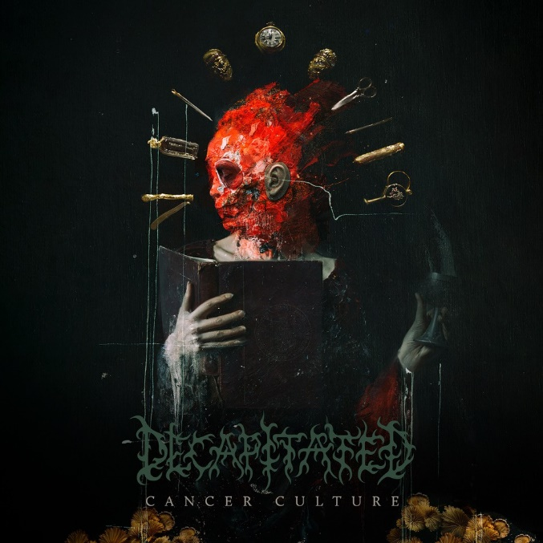

DECAPITATED

«Cancer Culture«

OUT: May 27th, 2022
Line up: | DECAPITATED online:
Waclaw ‘Vogg’ Kieltyka | guitar  James Stewart | drums  Paweł Pasek |bass  Rafał ‘Rasta’ Piotrowski | vocals | decapitatedband.net  facebook.com/decapitated  instagram.com/decapitatedband  youtube.com/decapitated  twitter.com/decapitated
“Heads Above The Rest.” – Kerrang!
Across eight studio albums, DECAPITATED grew from the adolescent dream of teenagers from a small Central European town to one of the leaders of the metal genre. Each successive album further expands the band’s sound with genre-bending authenticity and integrity. As Metal Injection rightfully observed, “any self-respecting death metalhead knows the name well.”
DECAPITATED’s music is a weapon forged by four young men from a historic medieval-fortified town in Poland, which catapulted them to the top of a worldwide subculture. Like a rose in the devil’s garden, the DECAPITATED story builds triumph from tragedy. The gleeful grotesquery of extreme metal imagery and rifftastic bludgeoning beckons listeners to uncover broader truths.
Upon the release of 2017’s Anticult, Metal Hammer declared DECAPITATED “a serious successor to the likes of Pantera and Lamb Of God – a band who can draw new legions into the metal world as its new champions.” Their diverse follow-up, 2022’s Cancer Culture, delivers on that promise.
Instantly recognizable devastation and deceptively sinister hooks abound. Freshly minted DECAPITATED anthems like “Last Supper,” “Hello Death,” “Just Cigarette,” “No Cure,” “Iconoclast,” and “Cancer Culture” shimmer with sonically sharp production and unrelenting bombast.
There’s also a newly increased emphasis on melody, even venturing into darkly romantic territory. Wacław "Vogg" Kiełtyka (guitar), Rafał "Rasta" Piotrowski (vocals), Paweł Pasek (bass), and James Stewart (drums) are at the top of their game, delivering the goods at peak performance. Jinjer vocalist Tatiana Shmayluk and Machine Head frontman Robb Flynn make guest appearances.
“We’ve changed our path from record to record every time,” points out songwriter and creative mastermind Vogg. “Each album differs from the previous one, which I think is somehow a tradition in our band, a hallmark. Of course, it is not something we plan to do; it comes naturally. I like to explore new musical territories and always be honest with the feelings I put into what I create. I don’t plan to make something more melodic, romantic, brutal, or whatever. It’s very organic, whichever way I’m feeling in the moment. That might be too risky for some bands, but our fans know that we never deliver the same music twice. We want to surprise and show them how the music is versatile.”
Which isn’t to say DECAPITATED ever stray from the combustible elements which spawned them. Cancer Culture is technical and intense, with defiant blast beats, double bass, and speed.
“There is always something new for this kind of music, but at the same time, it will be based on my roots,” Vogg says. “Florida death metal bands, Bay Area thrash, Polish death, and thrash; what I loved growing up.”
Set on the descending plains of a mountain range amid a dense forest, Krosno boasts a 14th-century Gothic church, a Subcarpathian museum, and stunning artisan glassware. In this Polish town, teenage music student Wacław "Vogg" Kiełtyka discovered records from bands like Morbid Angel, Cannibal Corpse, Metallica, and Machine Head. The guitarist and his younger brother, drummer Witold “Vitek” Kiełtyka, cofounded DECAPITATED in 1996, inspired by a wide range of technical death, blackened thrash, and local heroes, like KAT and the world-renowned Vader.
Death and black metal reigned supreme in the Polish scene of the 1990s, where Behemoth originated as well. In fact, a Vader song called “Decapitated Saints” inspired the band’s moniker.
The organic musical chemistry between the Kiełtykas was akin to the brotherly connectivity and vibe driving Pantera, Gojira, and the classic era of Sepultura. In 2006, Kerrang! praised the first three DECAPITATED albums - Winds of Creation (2000), Nihility (2002), and The Negation (2004) – as “superbly conceived and executed eruptions of technical brilliance and razor-sharp songwriting that turned these youthful Poles into one of the genre’s most widely respected bands.” That year’s Organic Hallucinosis further perfected Vogg’s penchant for blending extremity with catchy hooks.
The rule-breaking ferocity and invention of the first four albums reinvigorated death metal, as DECAPITATED inspired a new generation of bands who followed suit. Sadly, this era came to a shocking end in late 2007. While touring Russia, the band’s bus collided with a large truck near the border with Belarus. Both Vitak and then-singer Adrian “Covan” Kowanek sustained severe head injuries. Tragically, Vitak passed away in a Russian hospital a few days later. He was just 23.
Vogg summoned the courage to continue, in honor of his brother and what they created, and returned with a new incarnation of DECAPITATED and the fiercely adventurous comeback album, Carnival is Forever (2011) featuring new vocalist Rafał "Rasta" Piotrowski. Blood Mantra (2014) introduced
bassist, Paweł Pasek. Blabbermouth declared it “perhaps the most poised and gutsy” DECAPITATED album, adding “its courageous bends make it a turbulent but pleasurable ride.”
“Every time, I’m trying to make it just a little bit more modern and trying to put more of myself into it,” Vogg explains. “And just trying to continue that in every possible way that I can.”
As it’s been since the beginning, Vogg is the primary composer, and his guitar style remains recognizable. Anticult blended even more diverse sounds: death, grind, and black metal with atmosphere; grooving stoner rock; and postmodern metal crunch; across deliciously varied tempos. They managed this feat without sacrificing the signature sound, harkening back to the greatest strengths of the early material. Somehow, Cancer Culture upped the ante anew.
The pandemic-related shutdown resulted in the most time DECAPITATED had to make an album since their debut. Before entering the studio, the band rehearsed often. Pre-production and the sessions took 15 months.
“It was a really creative time like I’ve never had for 20 years,” Vogg says. “Every year, I was only home from tour for a few months. Some bands are probably touring too much and not spending enough time creating music, resulting in a lack of ideas. I truly believe that because of these crazy times right now, we’ll have several great albums from so many bands.”
DECAPITATED always sought the best production possible, with the highest sonic richness, and this time was no different. In the past, the band hired top-tier producers like Daniel Bergstrand (Meshuggah, In Flames) and the Hertz Brothers (Behemoth, Vader), and the best engineers in Poland, including Tomasz Zed Zalewski, who won a Polish Grammy and is many times nominated.
Cancer Culture sounds brilliant, modern, and tasty. “There is no place for any fake, plastic, bullshit drum machine or anything like that,” Vogg insists. “It’s all organic, pure, and clear, showing the true face of the band. Vogg and company entrusted the Cancer Culture mix to David Castillo at Sweden’s Fascination Street Studios / Studio Gröndahl (Sepultura, Carcass, Opeth, Katatonia), and legendary American producer Ted Jensen (Metallica, Slipknot, Pantera, Machine Head, Korn).
The devoted supporters who traveled to see DECAPITATED on international tours with the likes of Lamb Of God, Meshuggah, Soulfly, Fear Factory, and Suffocation over the years will recognize the ever-present pummeling backbone. Longtime fans and newcomers alike will connect to the variety of atmospheric depth throughout Cancer Culture’s ten boundlessly energetic and creative tracks.
Cancer Culture is no less rich thematically. As he did with 2011’s Carnival Is Forever, Journalist Jarek Szubrycht composed the lyrics and album title for Cancer Culture. “He did lyrics for us for the second time, and those lyrics are amazing,” Vogg says. “He’s not a typical writer. It’s all about what we are doing as people, the current times, how we never seem to learn from our mistakes.”
Szubrycht explains: “These are songs about the disproportion between the dreams, ambitions, and aspirations of humanity - and people as individuals - and the actual human capabilities. About the fact that every power and every triumph are innately bound to fail. And also, how religion is a sophisticated lie that we want to believe so much because we are afraid of nothingness.
“We are so stupid and short-sighted that we destroy everything we touch, including the Earth that gave birth to us and nourishes us,” he continues. He adds that the lyrics “tackle the issues regarding the internet, a great invention (and more broadly - technology), as the space where we mainly pour out frustration, spread superstition and lies, fuel hatred, and feed our low self-esteem. All the social media power trips and anger sprees are not worth shit because we are only a temporary aberration, a micro-error on the cosmic scale. There will be no trace left after in a moment's time. They are lyrics painted with disappointment, pessimism, and a lack of illusion.”
Szubrycht is the vocalist for long-running avant-garde metal band Lux Occulta, whose lineup includes Vogg on guitar. The band isn’t Vogg’s only project outside of DECAPITATED. As part of his improbable and inspirational story of perseverance and undeniable creative strength, Vogg joined Vader for a brief stint in 2008. In September 2019, he became the lead guitarist in Machine Head.
“If you told me 25 years ago, in my neighborhood in the South of Poland, that I would be in Machine Head, sharing riffs with Robb Flynn,” Vogg marvels. “It’s simply incredible. It means that everything is possible in your life. That gives me the faith to believe that I can achieve even more in my career. The dreams we have when we are kids, things we can barely imagine, can happen.”
Flynn contributes a hauntingly beautiful vocal to the Cancer Culture track “Iconoclast.” “Clean vocal singing is a really new thing in DECAPITATED,” Vogg notes. “It’s really unique and amazing.”
Shmayluk, a formidable screamer, went the clean vocal route as well, enriching “Hello Death” with a moody vibe and an undeniable hook. “Jinjer is one of the more interesting acts in metal music of the last few years,” Vogg says. “And Tatiana’s vocals on the song will surprise some people.”
Driven by Vogg’s passion and integrity, the dual emphasis on creative invention and technical prowess maintains DECAPITATED’s stature as genre-leaders in 2022 and beyond. The band’s supporters continually demonstrate confidence and absolute certainty DECAPITATED will deliver.
“DECAPITATED was always about the music first,” Vogg says. “We never had an image. Our strength, our force, is to deliver great performances. Ever since we began touring, we’ve met fans who are musicians themselves or aspire to be. DECAPITATED is one of the bands from the modern death metal school, inspiring younger musicians. We also have older fans from the first four albums and another group from the more recent ones. I believe Cancer Culture will be the album to connect all of those groups. It is quintessential DECAPITATED.”
It's a huge step forward for the band and genre. DECAPITATED cannot wait to share it with fans!

Discography:
- Cancer Culture (2022)
- Anticult (2017)
- Blood Mantra (2014)
- Carnival is Forever (2011)
- Organic Hallucinosis (2006)
- The Negation (2004)
- Nihility (2002)
- Winds of Creation (2000)

